**MIS581: Self-Evaluation Form**

**Name:** Patrick Hauer

**Title/Topic of Speech:** The title is just Capstone Project: U.S. Organization – Final Project, but the topic of the paper is to help wit business development for Accumen.

**Please answer the following questions in detail (*meaning a minimum of two complete sentences per question*). Feel free to type your answers after the questions below. Your completed self-evaluation should be uploaded to the Week 1 Capstone Milestone page for the self-introduction speech and to the Week 8 Capstone Project page for the final assignment.**

How well did you explain and support your ideas?

-I believe I did a good job explaining and supporting my ideas. I provided evidence through different techniques like correlation and regression.

How effectively did you grab the attention of your audience?

-I think I did a good job grabbing the attention of the audience. I began with a quote and I got a good rating on strength of opening. VoiceVibes said I showed enthusiasm.

Did you state your purpose and speaking topic?

-I began the presentation by stating the purpose and scope of the project. I made sure to provide detail and rationale for my topic.

Did you state your thesis?

-It was not vey concise, but I did attempt to explain my thesis in the beginning of the presentation. It is often hard to boil it down to just one complete sentence.

How effective was your introduction?

-I believe my introduction was effective. I had a good enthusiastic opening and explained all the pertinent details to set the stage for the rest of the presentation.

Did you preview your main points?

-This part was difficult. I tried to explain the tools and techniques and goals of the project in the beginning, but it was not laid out in a very clean way like point 1,2,3.

How effectively did you use transitions?

-I was using the PowerPoint slides as a guide for the presentation so that helped with transitioning. I believe I did a good job with transitions.

Did you provide adequate nonverbal support?

-Although this was just a audio recording, I made a conscious effort to use hand gestures and other nonverbal support while I presented. I also was using my PowerPoint slides.

Did you use visual aids?

-I did use visual aids. I used the PowerPoint presentation, but VoiceVibes only records audio.

Did you cue for closure?

-I believe I did. I tried to provide a wrapping up tone to the conclusion of my presentation

Did you restate your thesis and main points?

-I could have done a better job with this, but I tried to restate the thesis and main points. Again, it can be difficult to restate everything concisely. Especially when there are time constraints.

Looking over your VoiceVibes report, what were your areas of strength? What areas do you need to work on? How do you plan to address these areas?

-My areas of strength for me are clarity and positive vibes. The main area that I need to improve on is variety of pitch. Apparently, I have a flat tone, and can be perceived as being boring. I also do not have a lot of upspeak, but my pace is in the ideal range. Please see more detail below.

Vocal Delivery

Your Vocal Delivery score was 6.39 out of 10. Nice work. Keep it up. There might be one or two ratings that are keeping you from your total best score. Find them and focus there.

Strength of Opening

Your Strength of Opening score was 4.37 out of 10. Good job, your voice had enthusiasm. Make sure your first 30 seconds will engage your audience.

Clarity

Your Clarity score was 7.97 out of 10. Clarity measures how easily your words are understood. Nice job! It's important to be clear and concise.

Click here to highlight areas where you did well

Pace

Your use of Pace was in the ideal range. Great job on pace! Your average rate is 4.29 syllables per second. This is within the ideal pace range for public speaking.

Click here to highlight areas where your pace was good

Pausing

Your use of Pausing was Too little. Make sure your pauses are full stops - at sentence ends and after you make important points.

Click here to highlight areas where you should think about using a pause to break it up

Upspeak

You did not use any upspeak. You don't have an issue with Upspeak. Upspeak is when a person raises their pitch at the end of a sentence as if they are asking a question.

Click here to highlight where you did some upspeak

Variety of Volume

Great job varying your volume! This helps you to emphasize points and keep your audience's attention.

Click here to highlight areas where you did best

Variety of Pace

Variety of pace measures how much you change up your rate of delivery. Great Job! You had a good amount of variety in your pace. This really helps engage your audience and highlight key takeaways

Click here to highlight areas where you did best

Variety of Pitch

Your variety of pitch was low. 58% of the time you had a flat tone.

Click here to highlight areas where you could add variety to improve your score

Word Spotting

Word Spotting located the following words. You used so 15 times. You used like 9 times. You used right 1 time. You used uh/um 10 times. You used i think 1 time.

Positive Vibes

The various Positive Vibes are all scored from 0 to 10. Your scores are as follows. assertive is 5.02. authentic is 6.17. captivating is 4.63. clear is 6.19. confident is 5.8. energetic is 4.92. organized is 5.38. personable is 5.47. persuasive is 5.06.

Click on the following positive vibes to see where you scored above average: assertive, authentic, captivating, clear, confident, energetic, organized, personable, persuasive

Negative Vibes

The various Negative Vibes are all scored from 0 to 10. Your scores are as follows. arrogant is 1.77. nervous is 2.62. boring is 4.03. belligerent is 1.5. condescending is 1.65. detached is 3.42. ditsy is 1.48. confusing is 2.53. pushy is 1.78. timid is 2.44. unapproachable is 3.19.

Click on the following negative vibes to see where you can improve: boring

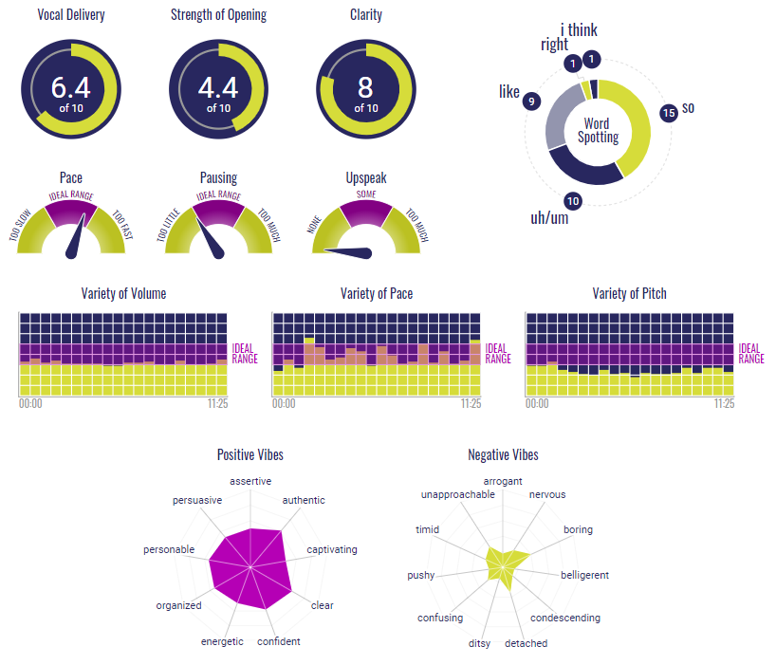

What is the link to your Youtube video?

<https://youtu.be/AwqbHEuANyY>